**First: Create a ROS workspace:**

**Steps:**

**1-**Create folder at any directory. (catkin_ws)

2-Create another folder within it. (src).

3-activate the workplace.

4-overlayed workplace.

5-check if workplace overplayed.

**STEP -1**

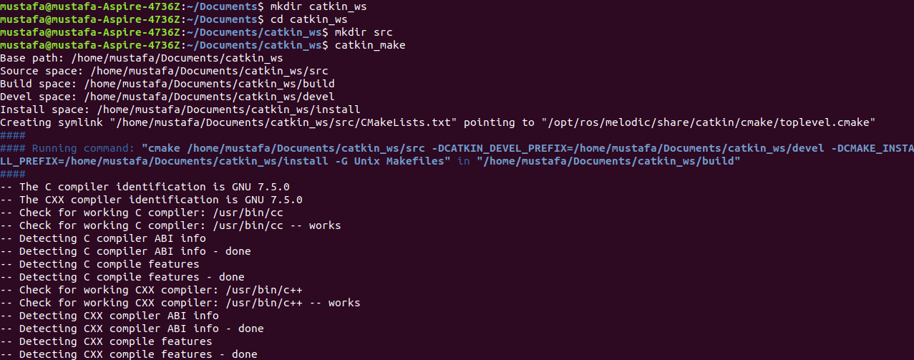

**STEP -3**

**STEP -2**

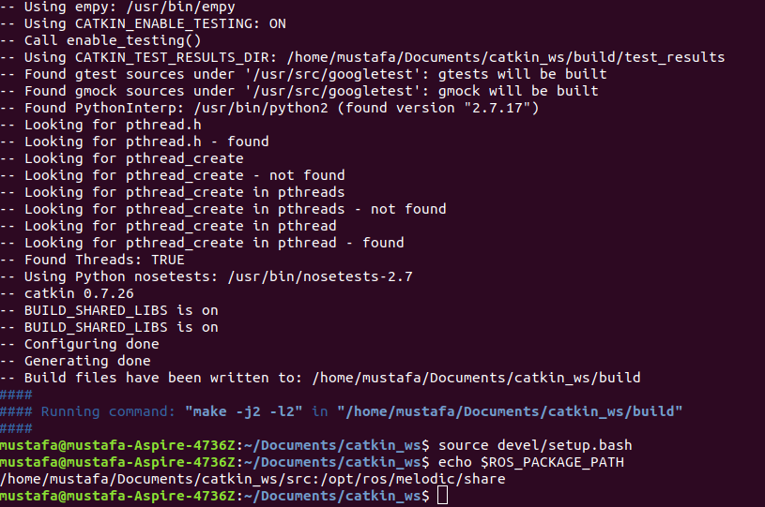

**STEP -5**

**STEP -4**

Seconde: create package:

1-change directory to src

2-create your package

3-create other packages (if need it)

4-activate the workplace. (AS STEPS ABOVE)

5-overlayed workplace (AS STEPS ABOVE)

**STEP -3**

**STEP -2**

**STEP -1**

VN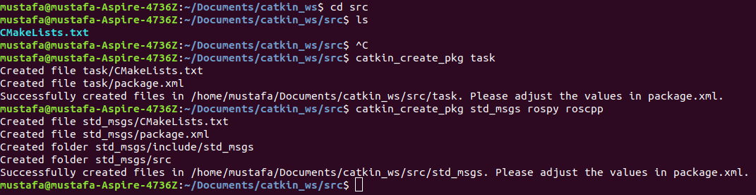

Third: create publisher subscriber node:

-write a python code in file text(text1.py) -publisher (

-write a python code in file text(text2.py)- subscriber

-change directory to catkin_ws

- run rosrun with package name and file (text1.py)

-open another terminal widow

-change directory to your package

-add the workspace to your ROS environment

-run rosrun with package name and file (text2.py)

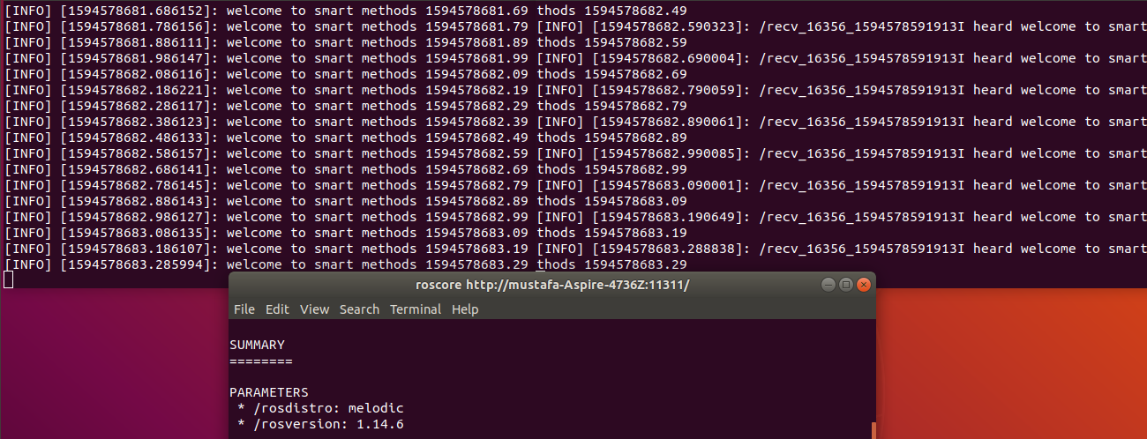

**subscriber**

**publisher**